Provider registry cheat sheet

Login Here: https://www.paeiproviderregistry.org/ using the same email and password from the old site. Click “forget password?” if you can’t get in.

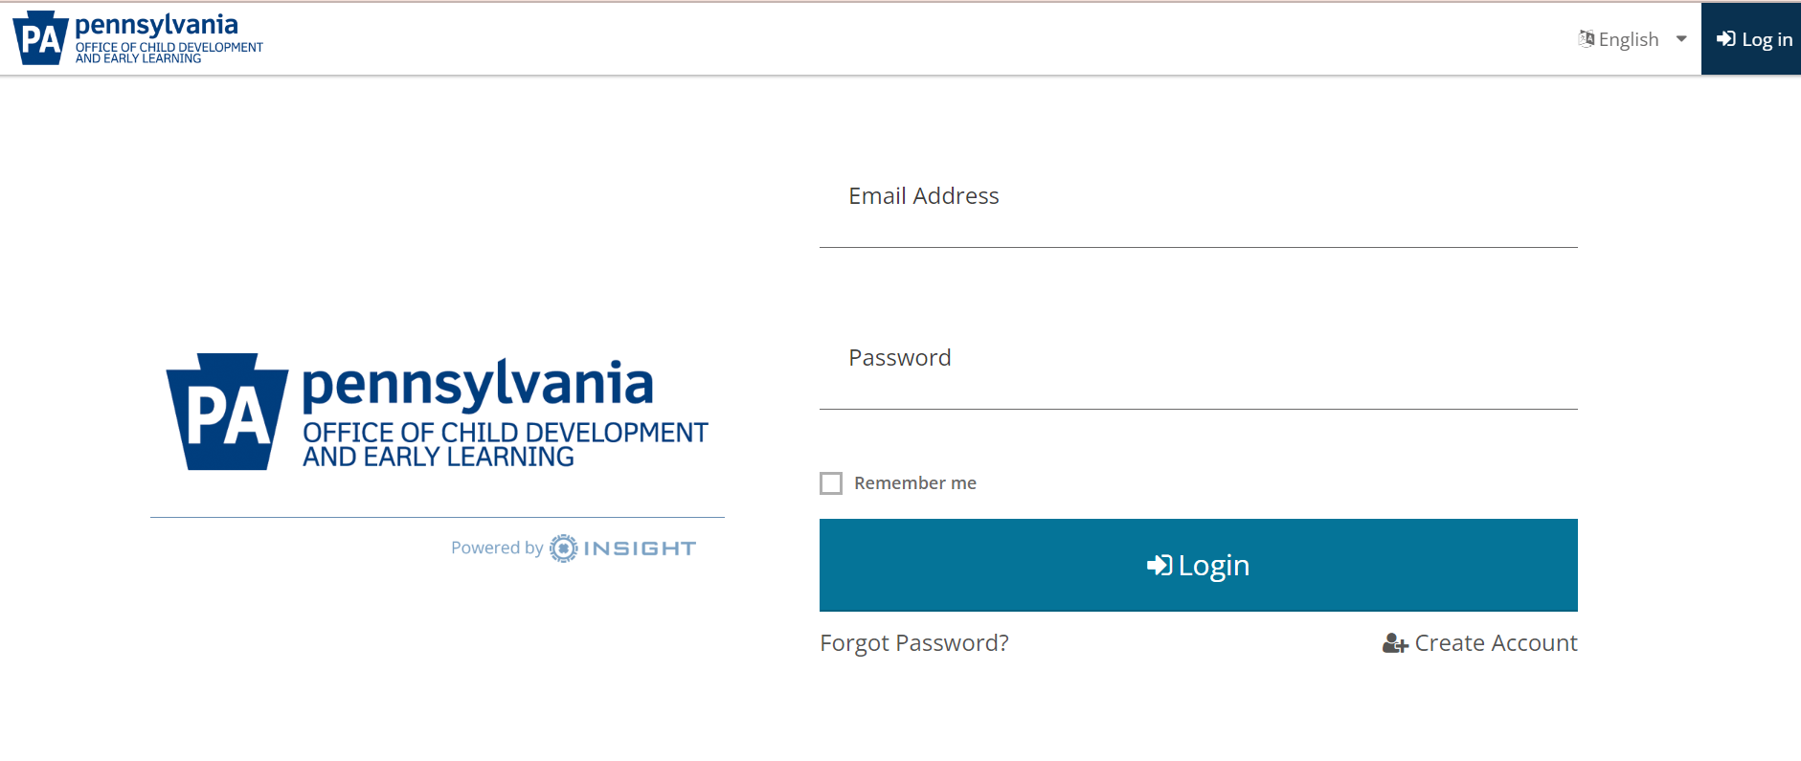

Once you are logged in, you will see this screen:

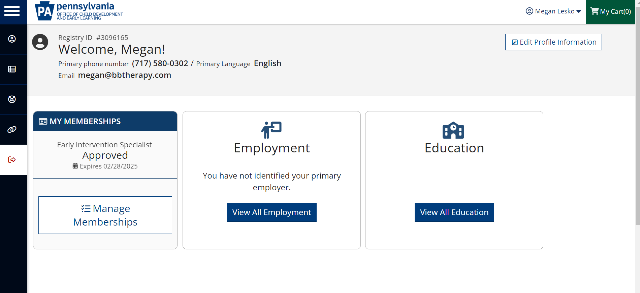

Click on “Education”. Please ensure that the following are in this section and up to date:
- CPR
- Mandated reporter training
- Fire safety
- Child abuse, criminal background, and FBI clearances
- Licenses for PT, OT, and STs.

Here is an example of what mine looks like. If the file folder is blue, then the certificate/license is attached. If it is red, you need to upload the appropriate certificate/license. If it says “verified” but the folder is red, please let me know and I can remove the verification so you can upload documentation.

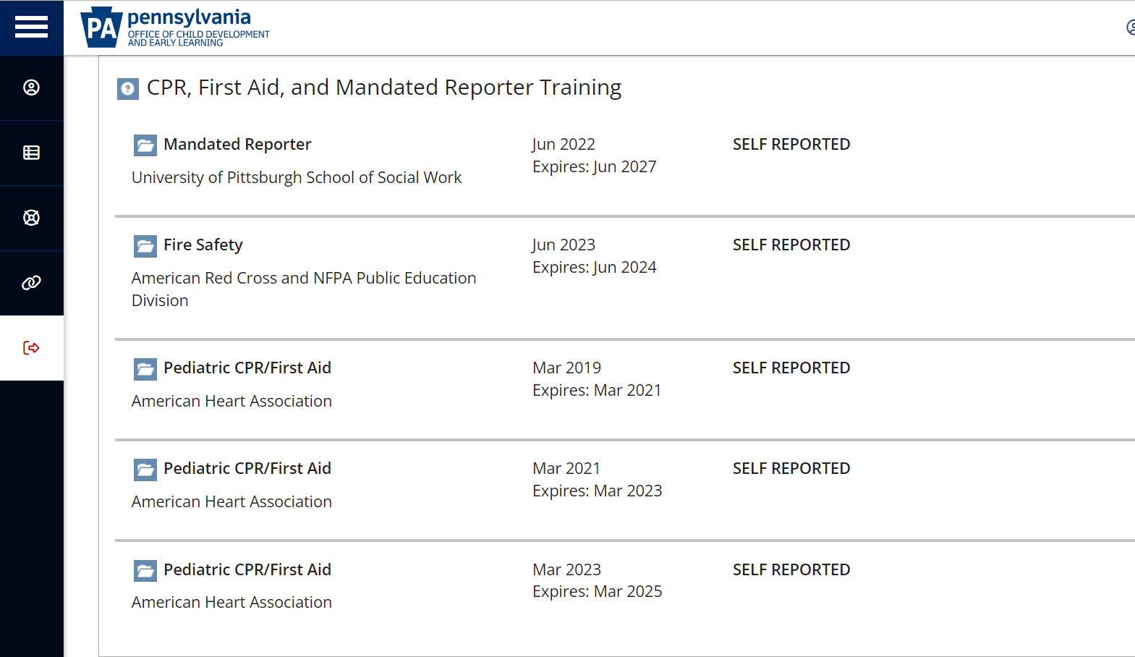

To enter trainings for the current training year, hover over the icon of a chart in the black strip on the left of the screen. The black section will expand with you hover over it and it will say “EI training.” Click on that.

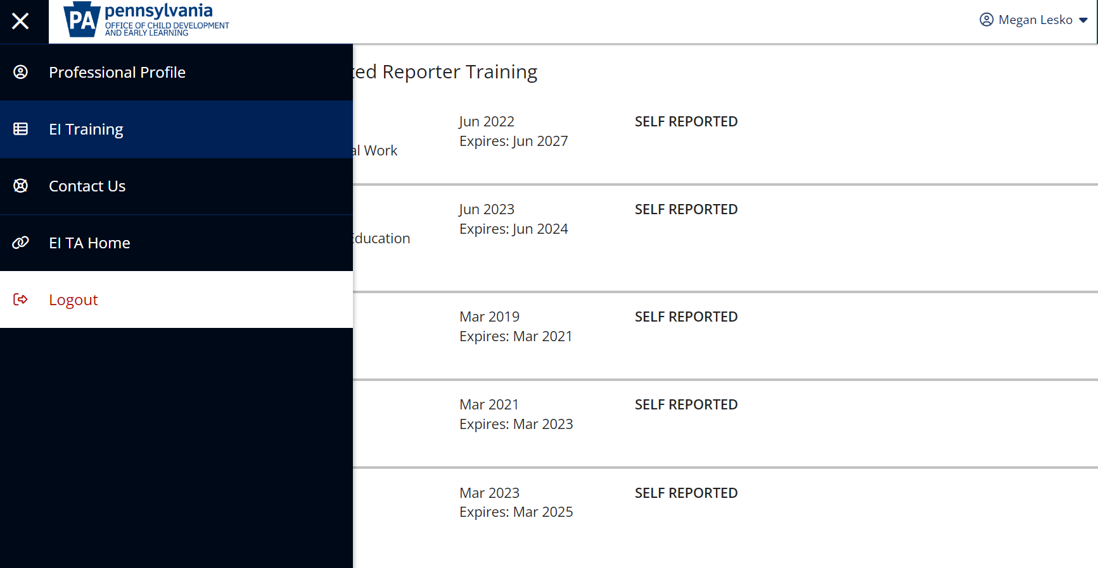

Once you are in, the trainings you have already entered should show below. Again, if the file folder is blue, then the certificate/license is attached. If it is red, you need to upload the appropriate certificate/license. If it says “verified” but the folder is red, please let me know and I can remove the verification so you can upload documentation.

To add trainings, click “Add Hours” in the top right of the screen to add new trainings:

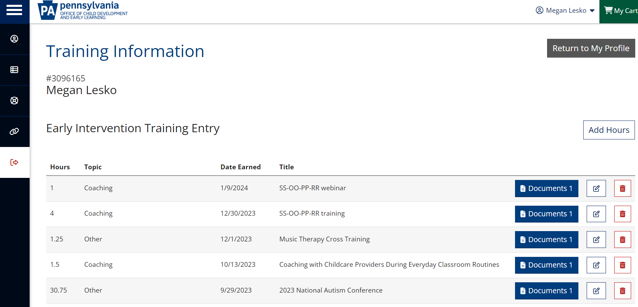

After clicking “add hours,” a new row will show up at the bottom of all of your trainings. This is where you enter the information about the training. There is a drop down with “—Select Topic –“. Most trainings do not fall under one of these. Those are for the mandatory annual topics, with the exception of “coaching”, which is where your FGRBI trainings and other coaching topics can go. As you see from my list, I have many “other” topics.

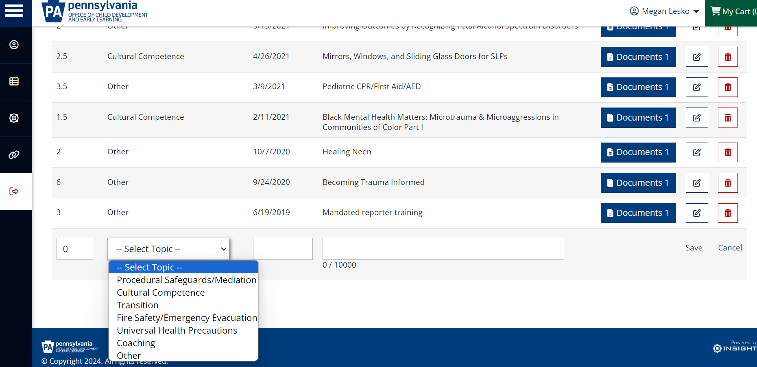

Fill in your training and hit “save”. You will upload your documentation in the next step.

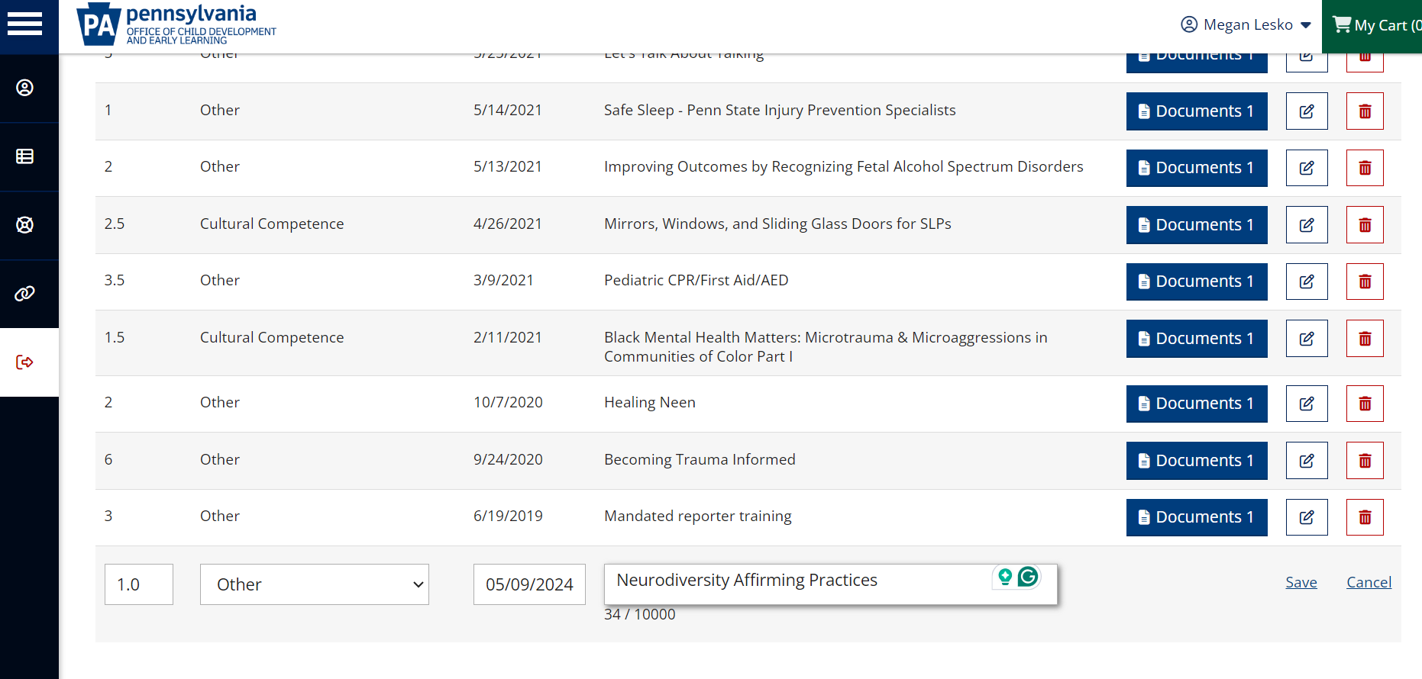

Once you hit “save,” your screen will refresh and your training will be listed at the top of the list. Click on “Documents” to upload training certificates.

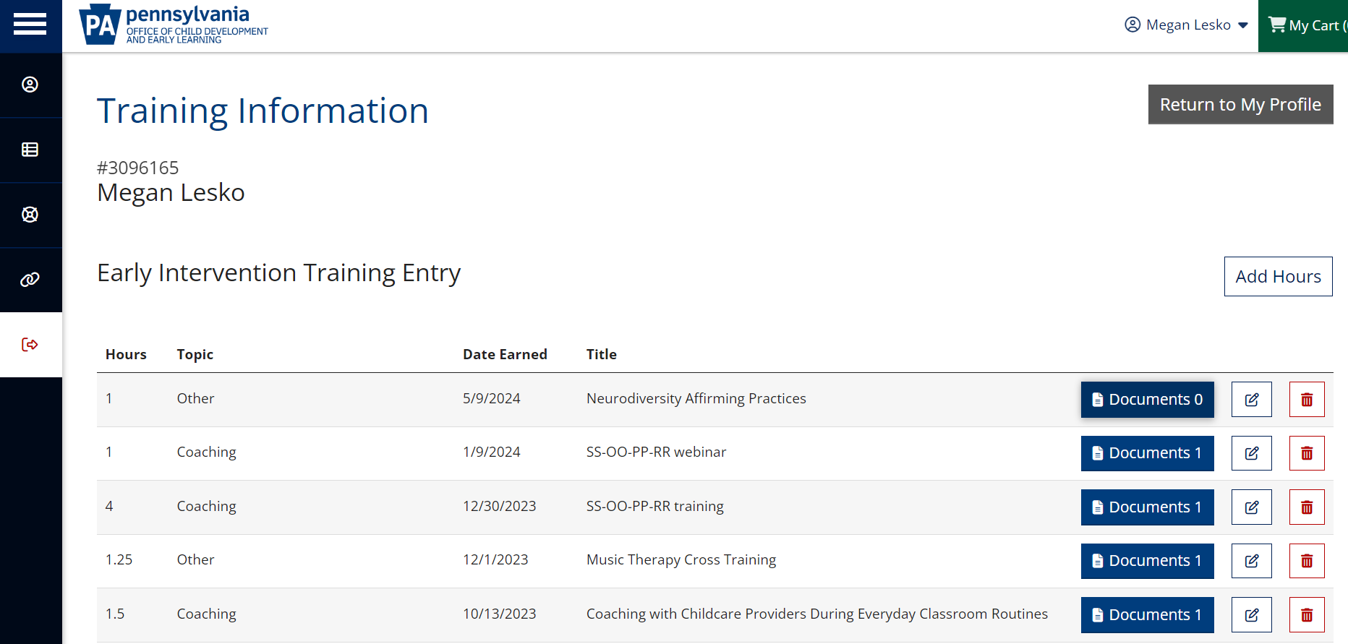

After clicking on “documents”, the screen below pops up. Click on “+ Files” to add documentation.

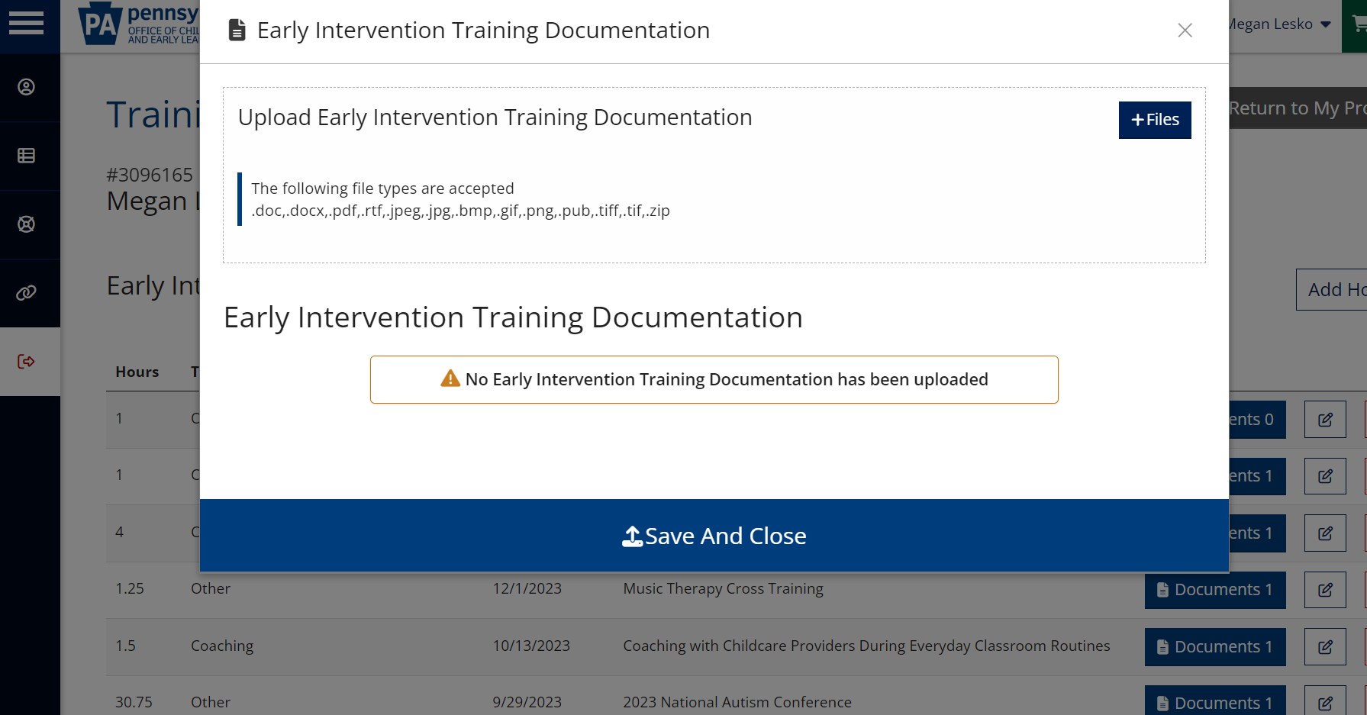

Once you add the file from wherever you stored it on your computer, you will see the file name listed as well as the message that “No Early Intervention Training Documentation has been uploaded. Click “Save and Close” to upload the document.

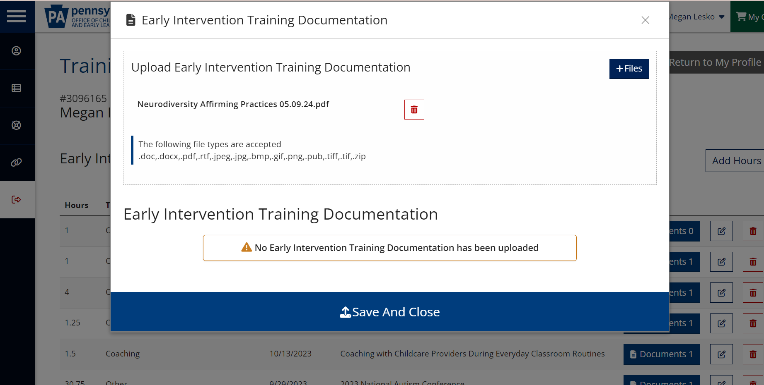

After hitting “Save and Close”, it should read “Documents 1” next to the training you just added:

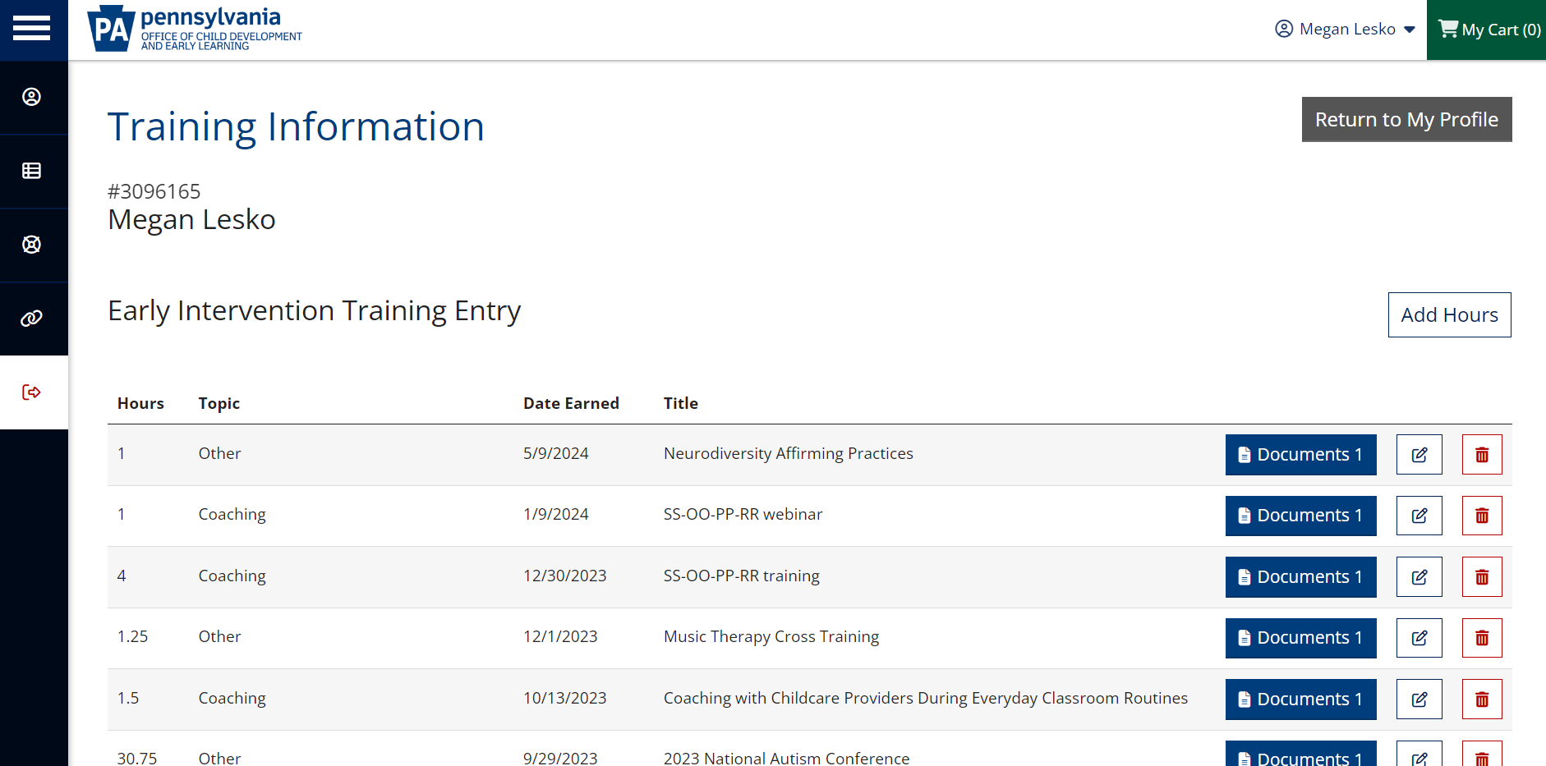

Important things to note about the education section:

  - If you take CPR, Mandated Reporting, or Fire Safety in the training year, it must be added both under “Education” and “EI training”. This ensures that that the training is current (education) and gives you credit for the training hours (EI Training).
  - If you do not have a certificate for something (ex: an article you read, presentation you did, etc), you can create your own certificate by completing the “Blank Training Certificate” in the document section of our website or attached to the 5/14/24 email with the subject line “IMPORTANT: Training hours for 23-24 and provider registry.”
  - The contact at the state for the provider registry is Heather Kawski and she can be reached at hkawski@pa.gov.

